MODULE 1: DEPLOYING WORDPRESS WEB APPLICATION BY USING DOCKER IN AMAZON WEB SERVICES

AND

MODULE 2: DEPLOYING WORDPRESS WEB APPLICATION BY USING JENKINS IN AMAZON WEB SERVICES

AND

MODULE 3: DEPLOYING WORDPRESS WEB APPLICATION BY USING SHELL SCRIPT IN AMAZON WEB SERVICES

BY

S.KOTESWARA RAO

1.DEPLOYING WORDPRESS WEB APPLICATION BY USING DOCKER IN AMAZON WEB SERVICES

PROCESS 1:- Lauching instance

* Creating and Launching an Amazon Linux EC2 instance

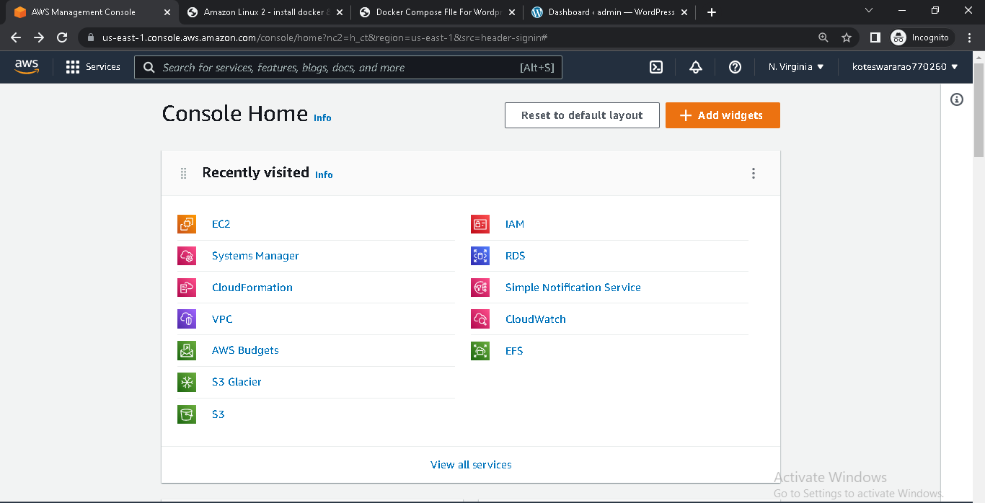

* Choose AMI

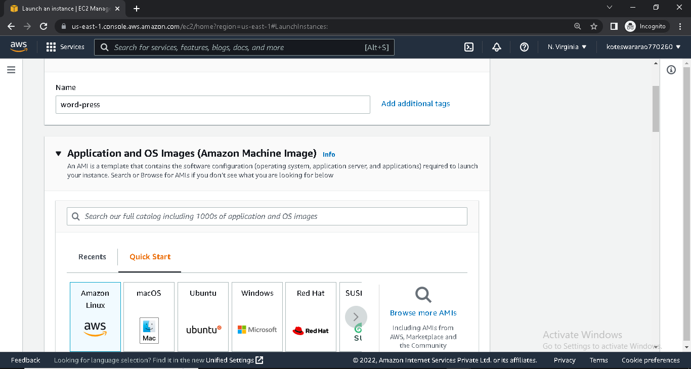

* Choose Instance type and Choose key pair

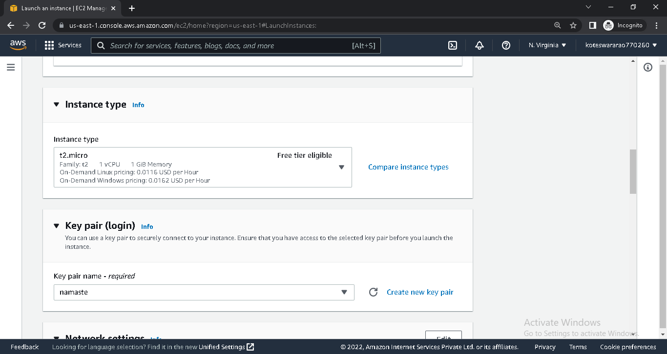

* Networking setting (select VPC and Subnets) and Select Security Group

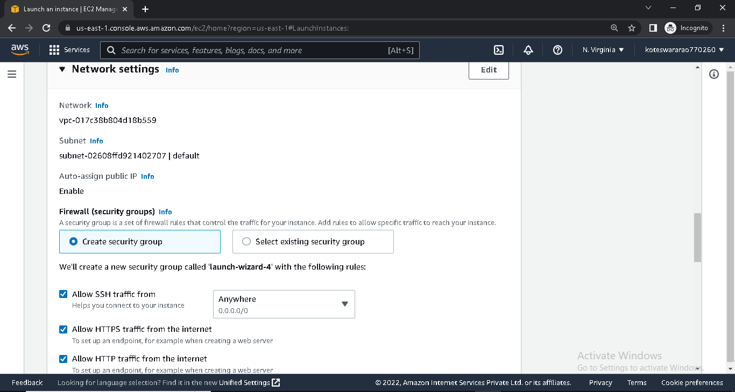

* Add storage and select no. of instance (if required)

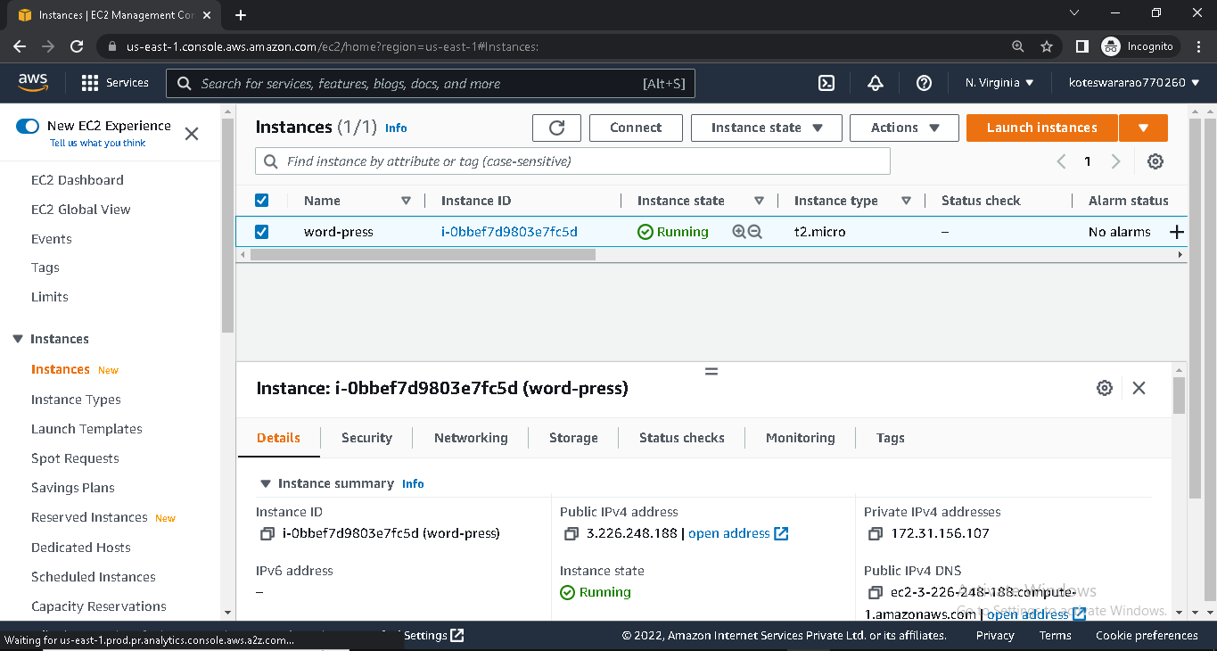

* Connect instance with SSH client into any one terminal(GitBash,

Putty, Power shell)

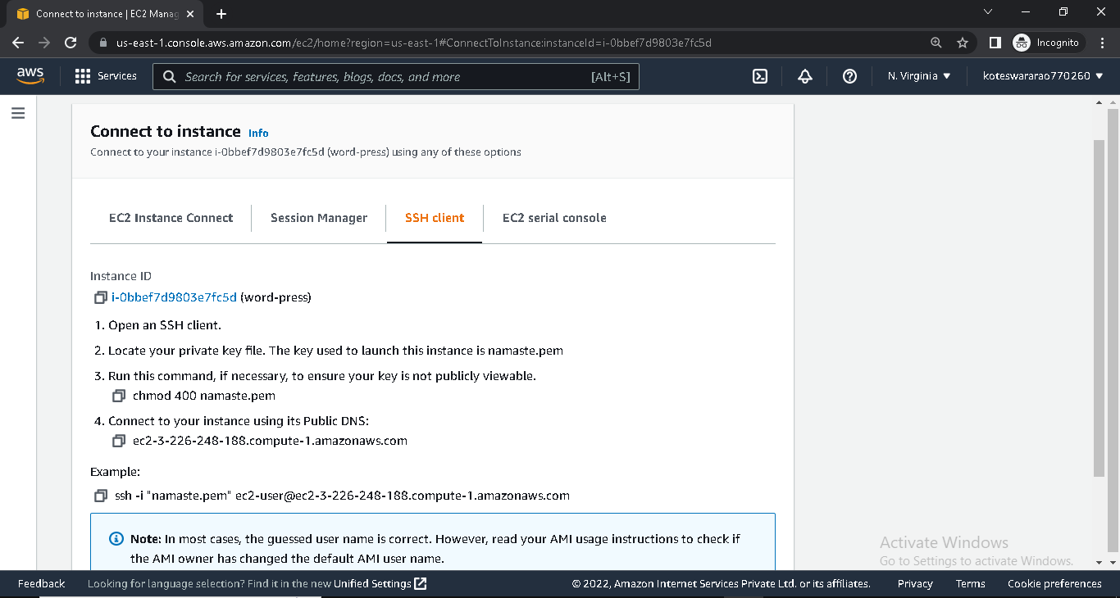

* Update local machine (instance) by using below command

Sudo yum update

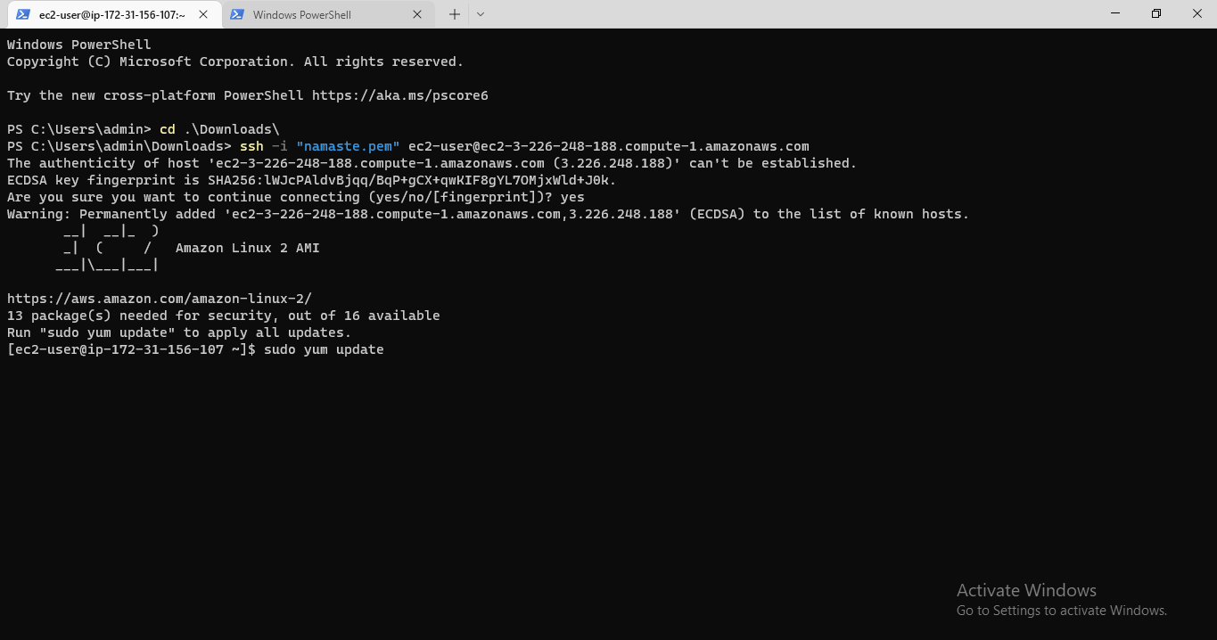

PROCESS 2: Installing GIT ,DOCKER AND REQUIRED REPO’S

* Install Git in instance using

Sudo yum –y install git

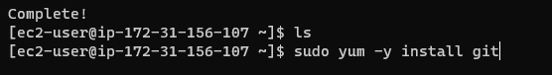

* Install docker in instance using

Sudo yum –y install docker

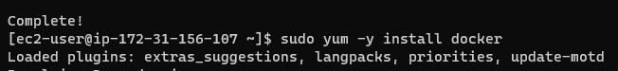

* Give permission for ‘Docker ‘ group using

Sudo usermod -aG docker ec2-user

* Start the docker service and enable docker service using

Sudo service docker start (or) sudo systemctl start docker

Sudo chkconfig docker on (or)sudo systemctl enable docker



* Install docker-compose using

Sudo curl –L http://github.com/docker/compose/release/download /latest/docker-compose-S(uname -s)-S(uname -m) -o /usr/local/bin/docker-compose



* Give executable permissions using

Sudo chmod +x /usr/local/bin/docker-compose

usermod.PNG

* Create a symbolic link

ln -s /usr/local/bin/docker-compose /usr/bin/docker-compose

systemlink.PNG

* Check docker-compose version

Docker-compose -version

PROCESS -3 **:- Creating wordpress setup for Docker images with help of YAML scripting**

* create docker-compose.yaml file to pull images from docker hub

sudo vi docker-compose.yaml

* docker-compose. Yaml file

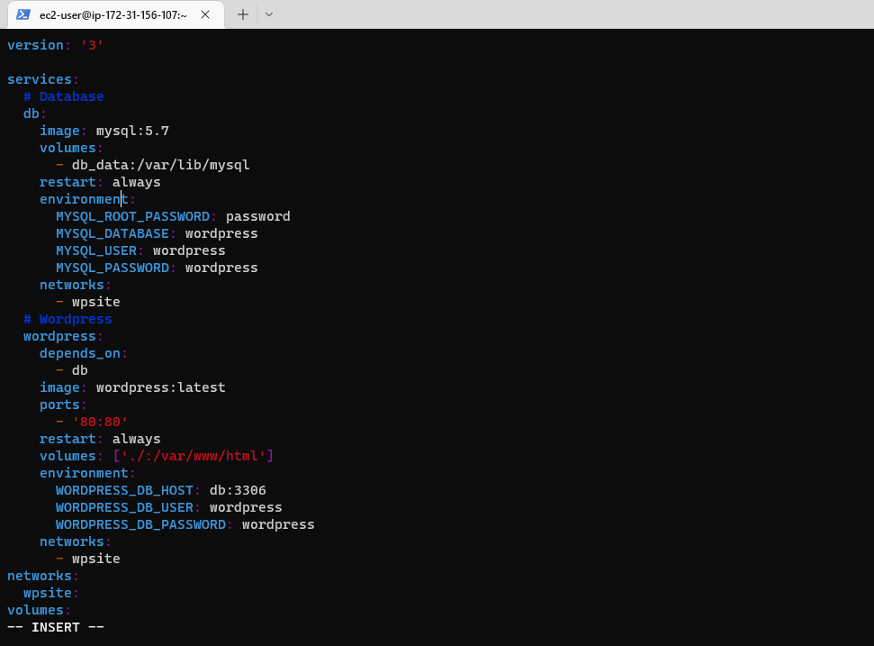

* Run thiscommand for puling the images

Sudo docker-compose up –d

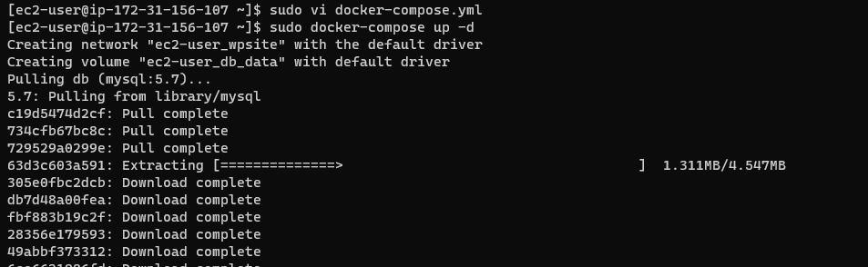

* By using docker-compose.yaml file it was pulling images are MYSQL and WORDPRESS

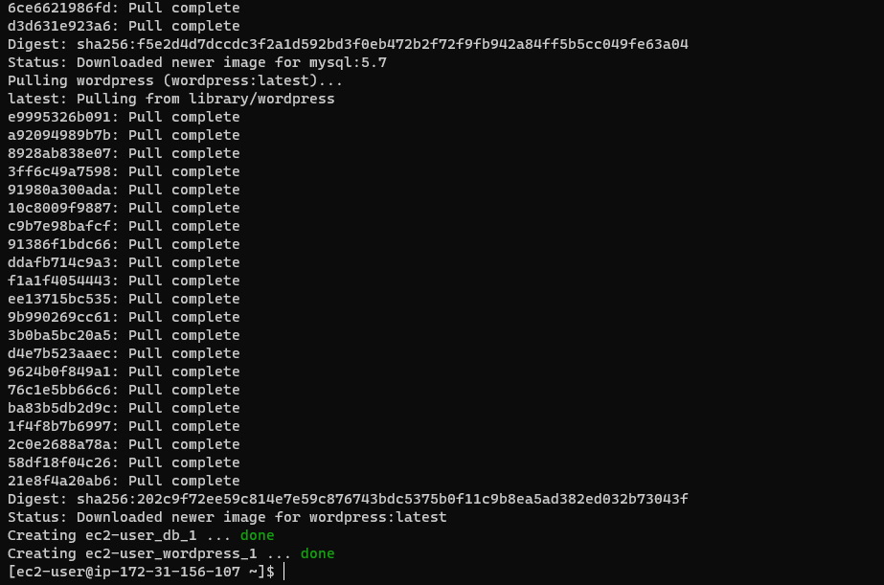

* Then I can get the list of running container by using below command

Sudo Docker ps

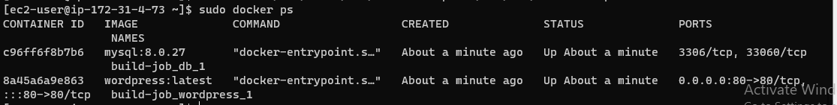

* Copy the public IP of instance check the wordpress

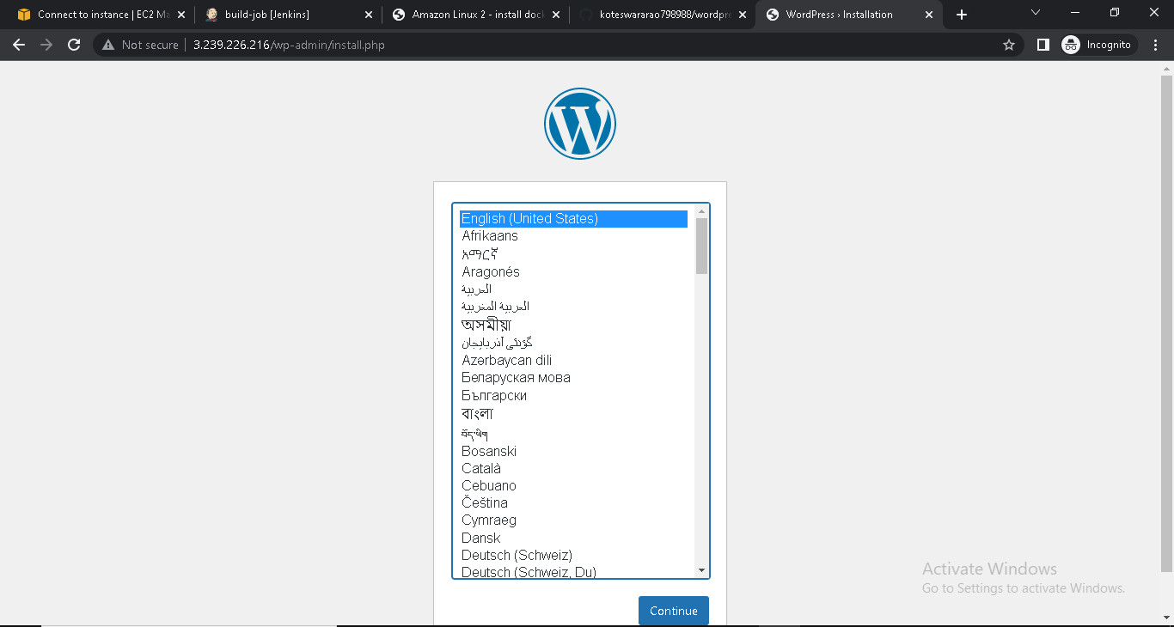

* Push the docker-compose.yaml file into git hub
* Make a folder

Sudo mkdir <name>

* Initialize the folder by using

Sudo git init <folder name>

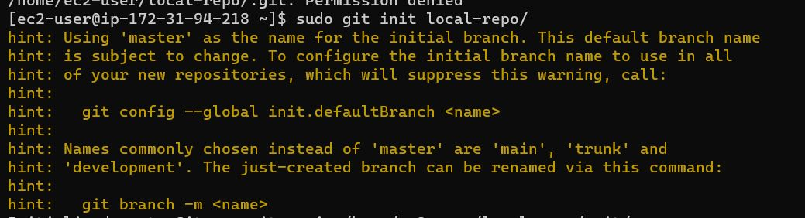

* Create remote repo with same name as local repo with out add readme. file
* In terminal, Change name of git branch from master branch to main branch by using command

git branch –M main

* Give connection to remote repo to local repo

git remote add origin <URL of your remote repo>

* push your file local branch to remote repo

git push –u origin main

* It will ask user name and password
* check it in github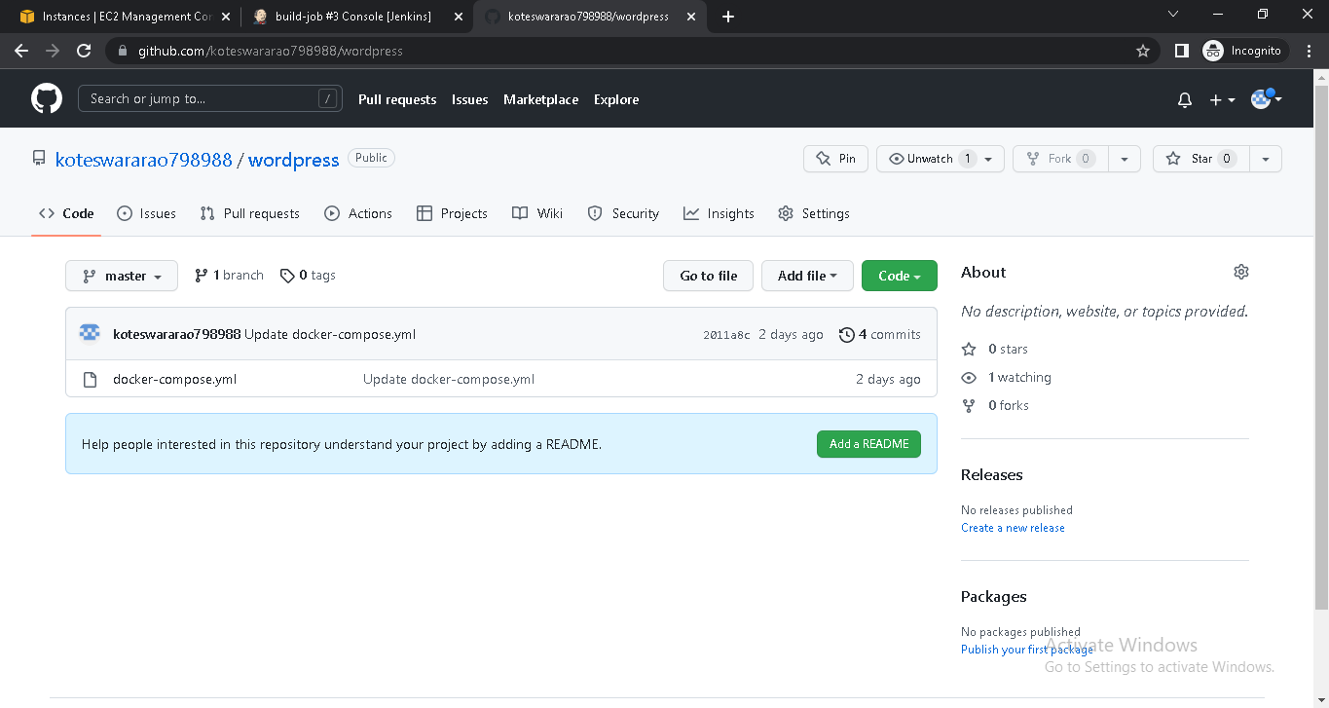

2. DEPLOYING WORDPRESS WEB APLLICATION USING JENKINS IN AMAZON WEB SERVICES

* Launch EC2 instance with Amazon Linux 2 AMI and required security group for JENKINS
* Connect SSH client into terminal
* Update the system
* Install Git in instance using

Sudo yum –y install git



* Install the java 11 version for the JENKINS

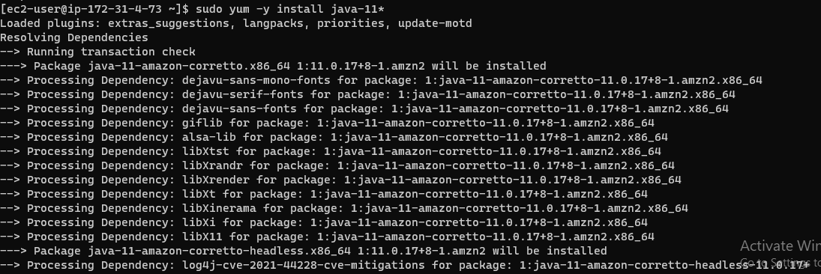

* Install Jenkins by using

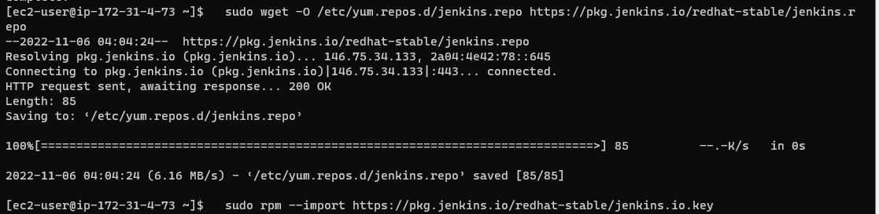

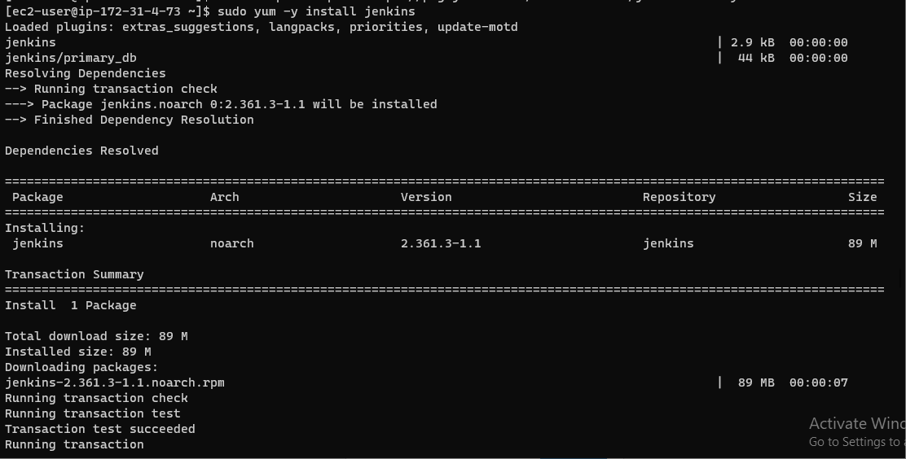

* Start the Jenkins service and enable it



* Select installed plugins
* Create a new job
* In job, clone the code of docker-compose.yml from git hub

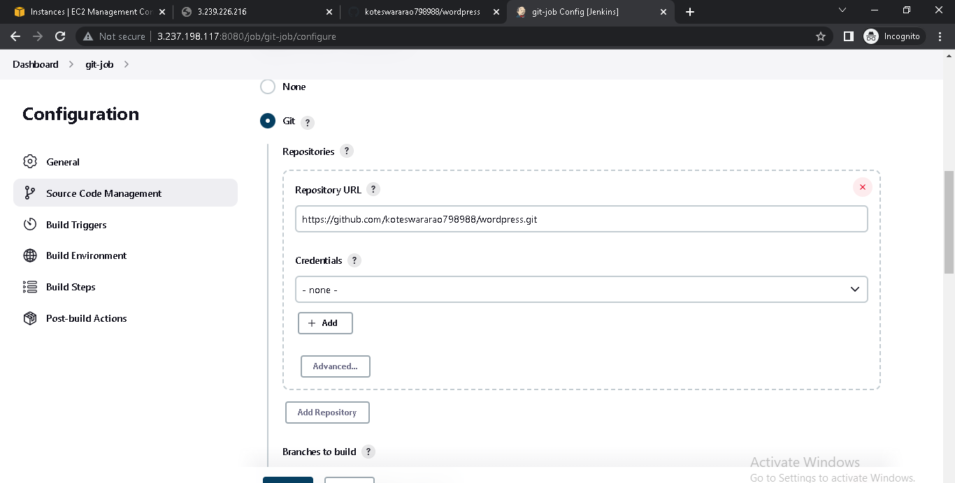

* Save it and build now

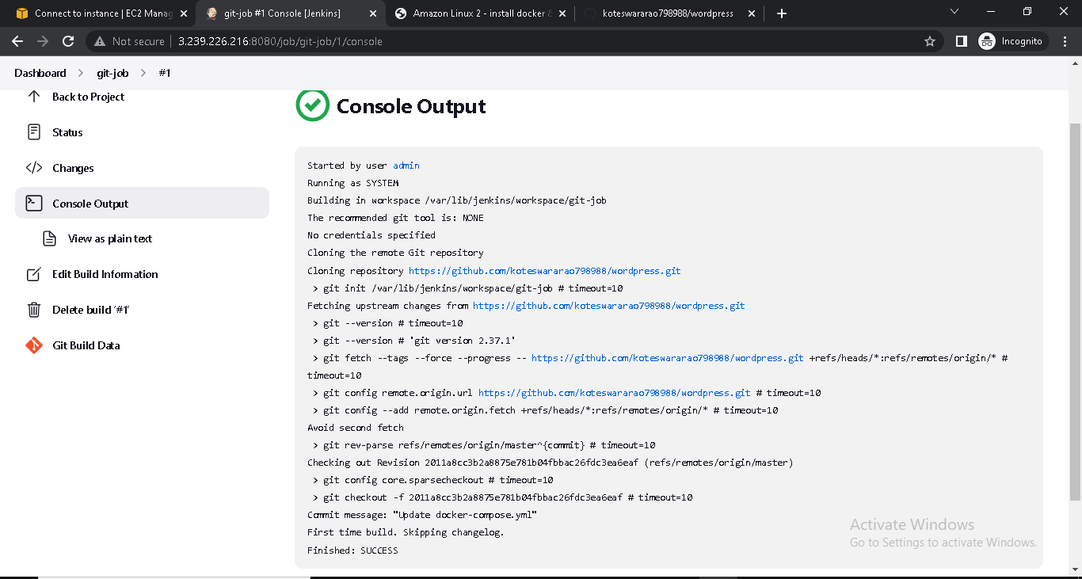

* Install docker in instance using

Sudo yum –y install docker



* Give permission for ‘Docker ‘ group using

Sudo usermod -aG docker ec2-user

usermod.PNG

* Start the docker service and enable docker service using

Sudo service docker start (or) sudo systemctl start docker

Sudo chkconfig docker on (or)sudo systemctl enable docker



* Install docker-compose using

Sudo curl –L http://github.com/docker/compose/release/download /latest/docker-compose-S(uname -s)-S(uname -m) -o /usr/local/bin/docker-compose



* Give executable permissions using

Sudo chmod +x /usr/local/bin/docker-compose

usermod.PNG

* Create a symbolic link

ln -s /usr/local/bin/docker-compose /usr/bin/docker-compose

systemlink.PNG

* Then , create another job select copy from previous job
* In build section select Execute shell
* In Excute shell give command for pulling the images from docker hub

Sudo docker-compose up –d

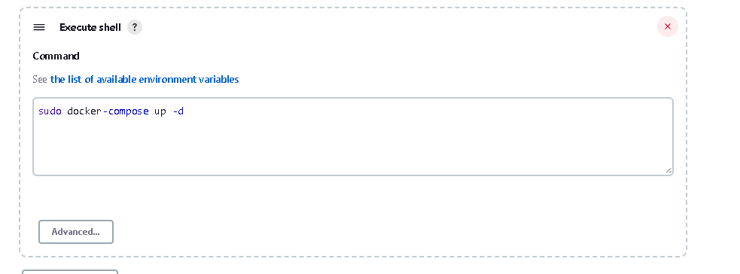

* save it and build now

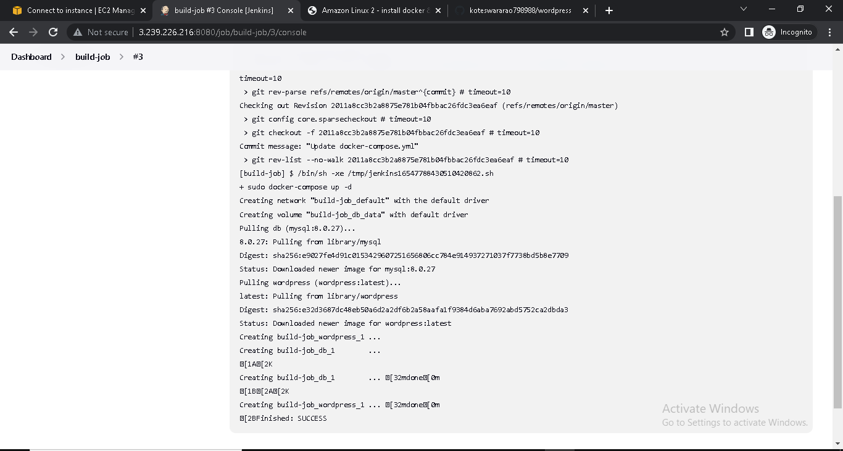

* check the docker container using

Sudo Docker ps



* Copy public IP of instance and check word press running or not



3. DEPLOYING WORDPRESS WEB APLLICATION USING SHELL SCRIPTING IN AMAZON WEB SERVICES

* Creating and Launching an Amazon Linux EC2 instance



* Choose AMI



* Choose Instance type and Choose key pair



* Networking setting (select VPC and Subnets) and Select Security Group



* Add storage and select no. of instance (if required)
* Go to advance details and write shell script in user data

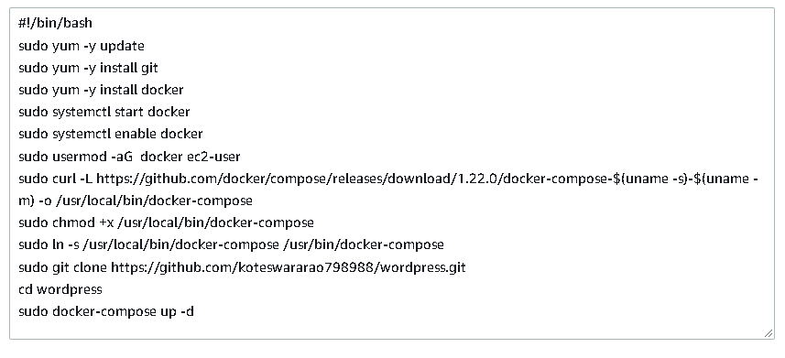

* Launch the instance
* Copy the public IP and check the word press

